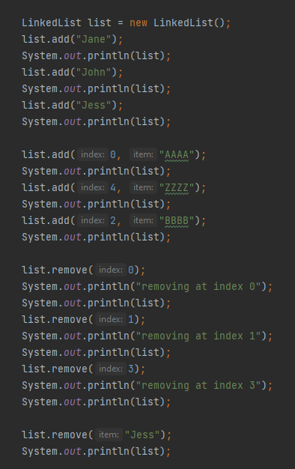LinkedList list = new LinkedList();

list.add("Jane");

list.add("John");

list.add("Jess");

list.add(0, "AAAA");

list.add(4, "ZZZZ");

list.add(2, "BBBB");

list.remove(0);

list.remove(1);

list.remove(3);

list.remove("Jess");

**LinkedList list = new LinkedList();**

list

@lk123

**list.add("Jane");**

list

Jane

null

@lk100

@lk123

**list.add("John");**

list

Jane

null

@lk100

John

@lk100

@lk200

@lk123

**list.add("Jess");**

list

Jane

null

@lk100

John

@lk100

@lk200

Jess

@lk200

@lk300

@lk123

**list.add(0, "AAAA");**

list

Jane

@lk90

@lk100

John

@lk100

@lk200

Jess

@lk200

@lk300

@lk123

AAAA

null

@lk90

**list.add(4, "ZZZZ");**

list

John

@lk100

@lk200

Jess

@lk200

@lk300

ZZZZ

@lk300

@lk400

@lk123

AAAA

null

@lk90

Jane

@lk90

@lk100

**list.add(2, "BBBB");**

list

John

@lk500

@lk200

Jess

@lk200

@lk300

ZZZZ

@lk300

@lk400

@lk123

AAAA

null

@lk90

Jane

@lk90

@lk100

BBBB

@lk100

@500

**list.remove(0);**

list

John

@lk500

@lk200

Jess

@lk200

@lk300

ZZZZ

@lk300

@lk400

@lk123

Jane

null

@lk100

BBBB

@lk100

@500

**list.remove(1);**

list

John

@lk100

@lk200

Jess

@lk200

@lk300

ZZZZ

@lk300

@lk400

@lk123

Jane

null

@lk100

**list.remove(3);**

list

Jane

null

@lk100

John

@lk100

@lk200

Jess

@lk200

@lk300

@lk123

**list.remove("Jess");**

list

Jane

null

@lk100

John

@lk100

@lk200

@lk123